Title 24pt bold
Subtitle (optional) 18pt

First Name Last Name ORCID ID; First Name Last NameORCID ID 14pt italics

DOI: https://doi.org/xxxxxxxxxxxxxxx/2024 (will be provided by editors)
Abstract 14pt italics bold
A short summary of the work. Briefly describe the publication's contents but as precisely and completely as possible. The abstract should be around 100 to 200 words long. Readers should be able to quickly see from the summary whether the publication is relevant to their research interests. The summary does not contain any images, tables or formulas; quotations or references should also be avoided. 12pt italics

Keywords: Keyword 1, Keyword 2, Keyword 3, 12pt italics

Introduction 18pt bold
This document contains guidelines for structuring and designing your manuscript for publication in the Open Online Journal “Acta Anglica Tirnaviensia”. It is also a format template that you can simply overwrite with the text of your manuscript. Please note the design instructions in this text, especially regarding figures, citation rules and gender-inclusive wording. Set a 0.5 cm indent for the first line of each paragraph in the text. Use spacing of 0 pt before, 6 pt after, and a line height multiplier of 1.15. The text should be written in the “Calibri” font in size 12 with 1.15-line spacing and should be justified. Exceptionally, large spaces between individual words caused by justified text should be corrected by adapting the text or by forcing word breaks at line breaks. If highlighting in the text is necessary, the formatting should be “italics”. Coloured or bold highlights and underlining are not permitted.

Notes on title, subtitle, names of authors 16pt bold
The title should be informative, but no longer than two lines. A subtitle (maximum of two lines long) can be used but does not have to be. The names of the authors should be given without a title. Each author’s full name should be followed by unique ORCID identifier. The name of the institution and address for all authors should be given in the footnotes on the first page of the document. At least one email address should be given in the footnote (for any queries from readers).

Notes on the numbering of sections
A further numbering level should only be added if there are at least two subsections. For example, if you create a section 1.1, you must also include a 1.2. Avoid having a single subsection under a section without a corresponding second subsection. This ensures a balanced and logical structure.

Material and methods
Preferably, follow the IMRAD structure of the manuscript for the fields of linguistics, linguodidactics, literature, and cultural studies. The IMRAD structure (Introduction, Methods, Results, and Discussion) is a widely accepted format for organising research papers across various academic disciplines. In the fields of linguistics, linguodidactics, literature, and cultural studies, the IMRAD format ensures logical clarity and coherence. However, due to the interdisciplinary nature of these fields, certain exceptions and modifications to the structure may be necessary based on specific content.
Given the diversity of research approaches in these fields, certain modifications to the IMRAD structure are allowed. Below are the possible exceptions based on the type of study:
- For theoretical or conceptual papers that are predominantly theoretical, the Methods and Results sections may be abbreviated or adapted. Authors may opt to include an extended Introduction or Theoretical Framework section that combines elements of Introduction and Methods to discuss the conceptual approach in detail. Results in such papers may focus on theoretical propositions or conceptual models rather than empirical findings.
- In literature and cultural studies, Results might be replaced with a Textual Analysis or Case Study section that explores key texts, artefacts, or cultural phenomena. Authors may choose to combine the Results and Discussion sections for a more fluid interpretive narrative, especially in analyses where results and their implications are closely linked.
- If your study relies heavily on existing linguistic theories, pedagogical approaches, or didactic frameworks, a detailed Literature Review section may precede the Methods section. This is particularly useful for papers focusing on curriculum development, language acquisition models, or teaching methodologies, where a solid foundation of prior research is critical.
- For historical or descriptive analyses (common in cultural and literary studies), Methods may focus more on source analysis (e.g., archival research, historical contextualization) rather than methodological tools. In such cases, the Methods section may be abbreviated, and more space should be given to the Discussion and Interpretation of the data within its historical or cultural context.
- For studies in linguodidactics (the science of teaching languages), a Pedagogical Implications section may be added after the Discussion. This section should address how the research findings can be applied in educational settings, providing insights into curriculum design, teaching strategies, or assessment methods.
In studies that require continuous interpretation of data (e.g., in literary or cultural analysis), the Results and Discussion sections may be combined to enhance readability. Authors should use subheadings to differentiate between the presentation of data and its interpretation, maintaining clear and logical flow.

Illustrations
When appropriate, use illustrations (figures, charts, graphs, tables) to visually support and clarify complex information, making your findings easier to understand. Include illustrations that directly contribute to the research. Each illustration should add value to the discussion or results. Ensure that all illustrations are high-resolution, clearly labeled and easy to read. Place the label below Graphs, Figures and Charts (e.g., "Figure 1: Title or brief description"). Place the label above the table (e.g., "Table 1: Title or brief description"). Avoid overcrowded or unclear images. All illustrations must be numbered (e.g., Figure 1, Table 2) and referenced in the text where relevant.

Tables, graphs, images and formulas
Only images created by the author are free of copyright, and images for which permission has been obtained for use in online and print publications may be used.

Figure 1: Here is the title or a short description of this graph. 11pt
Tables, graphics and images can be aligned left or centred, but the chosen format must be maintained throughout the document. If images are inserted, ensure that they have a sufficiently high resolution. For images published under a Creative Commons (CC) license, the source must be cited in accordance with the respective license. For more detailed instructions follow https://thevisualcommunicationguy.com/2014/07/14/can-i-use-that-picture/ .

File size of images
If a file contains a lot of images, this can make editing the file more difficult. You can find instructions on how to compress image files in MS Word here: https://support.microsoft.com/en-us/office/reduce-the-file-size-of-a-picture-in-microsoft-office-8db7211c-d958-457c-babd-194109eb9535

Citations, Sources and Bibliography
In the References, you will find some examples of source citations for articles in specialist journals, books, anthologies and sources that can be accessed online. The current APA style should always be used for citations and source citations, i.e. the sources of all citations or references should be identified in the form (last name, year, page number), for example, https://libguides.csudh.edu/citation/apa-7 . Indentations should be used in the bibliography. If a specific page number can be specified for a source reference, this should be stated. Multiple publications by the same author in the same year should be distinguished by lowercase letters added to the year, e.g. (Taylor, 2019a, p. 32), (Taylor, 2019b, p. 144). If there are two authors, the last names should be separated by an “&” (Smith & Brown, 2020, p. 124); if there are three or more authors, the citation should be in the form (Krüger et al., 2015, p. 15). References in the form “according to Halliday (1985, p. 79)” are also permitted. Websites as sources should be avoided if possible; the web address of an online source should not be mentioned in the main text but in the bibliography. Direct quotations should be marked as such using double quotation marks, e.g. “The interaction between morphology and syntax in heritage speakers presents unique challenges for linguistic theory, particularly in the domains of tense and agreement” (Jones, 1921, p. 45). The period therefore comes after the source reference. Longer quotations (more than 40 words) should, however, be separated from the body of the text, e.g. by a separate paragraph and indentation (block quotation). As Smith and Johnson (2022) noted:
The study of bilingualism has highlighted the complexity of language interaction in the brain. Bilingual speakers often engage in code-switching, which is not random but governed by syntactic and pragmatic rules. This phenomenon challenges traditional views of language compartmentalization and suggests that language systems are more fluid than previously thought. (p. 112)
In a block quotation, the period comes before the source reference. In block quotations (used for quotes over 40 words), the text is indented 1 cm from the left and right margins, and no quotation marks are used. The page number is provided at the end of the block. You can find more information about citations here:
https://libguides.csudh.edu/citation/apa-7

Acknowledgement:
Formally recognize individuals, institutions, or organizations that have contributed to the development of the manuscript but do not meet the criteria for authorship. This may include technical assistance, financial support, provision of research materials, or intellectual contributions that do not qualify for full authorship credit.
References

Halliday, M. A. K. (1985). Linguistic function and literary style. In J. J. Webster (Ed.), Language, context, and text: Aspects of language in a social-semiotic perspective (pp. 45–75). Deakin
Jones, A. M. (2021). Heritage language acquisition and syntactic theory. Journal of Linguistic Inquiry, 52(1), 34–58. https://doi.org/10.1234/jli.2021.0456University Press.
Smith, J., & Brown, A. (2020). The role of syntax in bilingual language acquisition. Journal of Linguistic Studies, 25(3), 123–145. https://doi.org/10.1234/jls.2020.01234
Smith, T. L., & Johnson, R. K. (2022). Bilingualism and cognitive flexibility: Insights from code-switching. Linguistic Studies in Multilingual Contexts, 38(2), 100–120. https://doi.org/10.4321/lsmc.2022.0023
Saussure, F. (1959). Course in general linguistics. Philosophical Library.
Taylor, J. (2019). Cognitive linguistics and the study of metaphor. Linguistic Research Online. https://www.linguisticsresearch.org/metaphor-study

11pt Calibri font. Text aligned right, repeated indents spaced 1.25 cm.

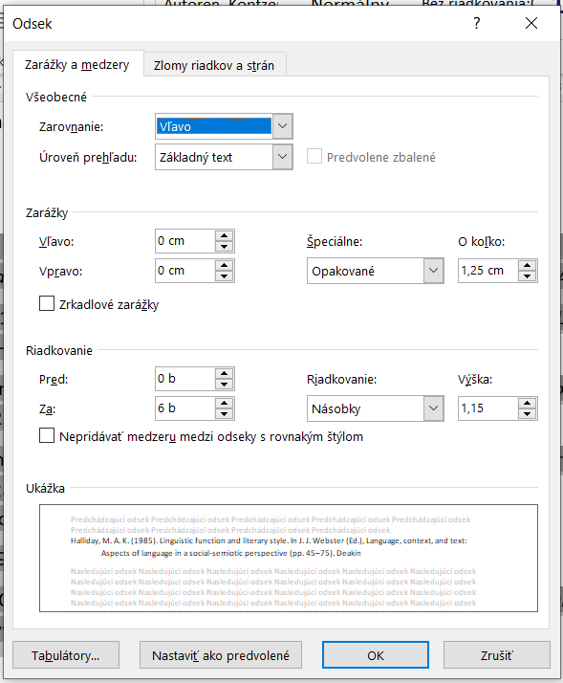

Faculty of Arts, University of Ss. Cyril and Methodius in Trnava, Slovakia, J. Herdu 2, 91701 Trnava, Slovakia E-Mail: xxxxxxx@ucm.sk
Faculty of Arts, Masaryk University, Arna Nováka 1/1, 602 00 Brno, Czech Republic E-Mail: xxxxxxx@phil.muni.cz

